***Happy New Year***

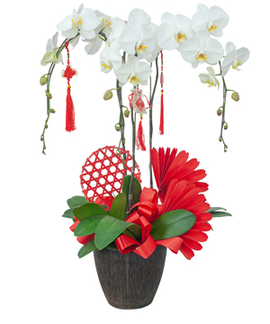

*Spring Prosperity"" consists of 5 branches of white phalaenopsis orchids decorated in high-grade porcelain pots are warm wishes at the beginning of the year for friends, bringing fortune, prosperity and feng shui to the owner. The living room has a small space, a nicely decorated orchid pot adds to the coziness and elegance of the house space.*